

PROJECT REPORT

AI STUDYBUDDY

YEAR : 2026 – 2027
COLLEGE NAME : K.C.S KASI NADAR COLLEGE OF ARTS & SCIENCE
CODE : UNM203
DEPARTMENT : COMPUTER SCIENCE
PROGRAM : B.Sc Computer Science
SEMESTER : V
PROJECT SUBMITTED TO: UNIVERSITY OF MADRAS /
VETRI THIRAN PAYIRCHI THITTAM
Course Name : AI Augmented Backend Development with
Node JS and MongoDB

TEAM LEADER:
JEEVALAKSHMI S
MEMBERS:
1.APARNA R
2.KEERTHANA A
3.LIKITHA V
GUIDED BY: Mrs. J.VIJAYALAKSHMI
SPOC NAME: Dr.K. LALITHAKAMESWARI
AI StudyBuddy - AI assistant for smarter learning and study support.
Description:
AI StudyBuddy is an intelligent learning assistant designed to make studying easier, more personalized, and more effective for students. Every student learns differently: some understand concepts quickly, while others need extra explanations, examples, and practice. Traditional learning methods often provide the same materials and pace for everyone, which can make it difficult for some students to keep up. AI StudyBuddy solves this problem by offering personalized academic support based on each student’s learning needs.The main purpose of AI StudyBuddy is to provide students with instant help whenever they need it. Students can ask questions about any subject, request explanations for difficult topics, create summaries from long notes, prepare for exams, and organize their study schedules. The assistant can explain a concept in simple language, provide examples, give step-by-step solutions, and create practice questions. This allows students to learn independently while still receiving guidance similar to having a study partner available at any time.
AI StudyBuddy can support a wide range of subjects, including Mathematics, Science, English, Computer Science, History, Geography, and more. For example, if a student is struggling with a mathematical equation, the system does not only provide the final answer. It explains each stage of the solution so that the student understands the method behind it. Similarly, in science subjects, difficult concepts can be explained through real-life examples, diagrams, comparisons, and simple definitions.AI StudyBuddy is a smart educational assistant that helps students learn at their own pace and improve their academic performance. It provides instant doubt clarification, personalized study plans, summaries, quizzes, revision tools, and progress tracking in one platform. By making learning more accessible, organized, and engaging, AI StudyBuddy can help students become more confident, independent, and successful learners.

Scenario-Based Case Study
Background
In many educational institutions, students face difficulties in managing their studies, understanding complex topics, and preparing effectively for examinations. Although schools and colleges provide teachers, textbooks, and classroom sessions, students often need additional support outside regular learning hours. They may hesitate to ask questions in class, lack access to individual guidance, or struggle to identify the subjects and topics that require more attention.
The background of this case study highlights the importance of using Artificial Intelligence in education to support personalized learning. AI StudyBuddy does not replace teachers; instead, it acts as a continuous learning companion that supports students before, during, and after classroom learning. By providing accessible, personalized, and timely academic guidance, the system can reduce study-related stress, improve understanding, and help students become more confident and independent learners.
Problem:
- Arun finds difficult subjects like Programming, Mathematics, and Data Structures hard to understand.
- He does not get enough time in class to ask all of his doubts.
- He struggles to find simple and syllabus-related learning materials online.
- Arun is not sure which topics he should study first for his examinations.
- He finds it difficult to manage his study time for different subjects.
- He feels stressed because he has many unfinished topics before the exam.
- He has trouble remembering important formulas, definitions, and concepts.
- Online quizzes only show his score and do not clearly explain his mistakes.
- Arun cannot easily identify the subjects and topics in which he is weak.
- He does not receive personalized guidance based on his learning speed and needs.
- He needs extra practice questions to improve his understanding of difficult topics.
- He requires a simple study plan to complete his syllabus on time.

Solution
Solution for the Scenario-Based Case Study
The solution is to develop an AI-powered learning platform called AI StudyBuddy. This system provides Arun with personalized study support whenever he needs it. He can ask questions about difficult topics and receive simple, clear, and step-by-step explanations. AI StudyBuddy can generate short notes, important formulas, examples, and practice questions based on his subjects. It can also analyze his quiz results, explain incorrect answers, and identify the topics where he needs more improvement. Using his exam date, available study time, and pending chapters, the system can create a daily study schedule. This helps Arun complete his syllabus in an organized way, reduce exam stress, improve his understanding, and become a more confident independent learner.
The backend processes incoming requests through secure RESTful APIs and performs the following operations:
Backend Operations
- The backend receives incoming requests from the AI StudyBuddy application through secure RESTful APIs.
- It verifies the user’s identity before allowing access to personal study data.
- It processes student questions and sends them to the AI engine for analysis.
- It retrieves relevant study materials, notes, and quiz data from the database.
- It generates personalized explanations based on the student’s learning needs.
- It creates study plans using the student’s subjects, goals, and exam schedule.
- It saves quiz scores and tracks the student’s learning progress over time.
- It returns the requested results securely to the application for the student to view.
By separating authentication, business logic, database operations, and AI processing into modular components, the backend ensures maintainability, scalability, and efficient request handling.
Usage
Student Usage
Student Usage
Students can use AI StudyBuddy to ask questions about difficult lessons at any time. They can get simple explanations, examples, and step-by-step answers for their doubts. Students can create short notes and practice quizzes for exam preparation. The system helps them make a daily study plan and manage their time effectively. It also shows their progress and helps them improve weak subjects.
Administrator Usage
The administrator manages student accounts and keeps the AI StudyBuddy system running properly. They can add, update, or remove student and teacher details when needed. The administrator monitors the study materials, quizzes, and user activity on the platform. They can check reports to understand how students are using the system. They also protect user data and make sure the application is safe and reliable.
Outcome
AI StudyBuddy helps students understand difficult lessons easily. It gives simple explanations and clear examples. Students can ask questions whenever they have doubts. This improves their confidence in learning.
The system helps students follow a proper study schedule. It reminds them to complete important topics on time. Students can use notes and quizzes for regular practice. This helps them prepare better for examinations.
Students can find and improve their weak subjects. The system gives practice questions based on their needs. They can track their progress and learn from mistakes. This can help them achieve better marks in exams.
Software Requirements
- Windows 10/11, macOS, or Linux: These operating systems support the development and use of the AI StudyBuddy application.
- Visual Studio Code: This code editor is used to write, edit, and manage the project source code.
- Git: This version control tool helps developers track and manage code changes.
- React.js: This library is used to create an interactive and user-friendly interface for students and administrators.
- HTML, CSS, and JavaScript: These technologies are used to design and develop the web pages of the application.
- Node.js: This runtime environment is used to run the backend server and application logic.
- Express.js: This framework is used to create secure RESTful APIs for the application.
- MongoDB: This database stores student details, study notes, quiz scores, and learning progress.
- Mongoose: This tool helps the backend application connect and manage data in MongoDB.
- OpenAI API or Similar AI Service: This service generates answers, summaries, quizzes, and personalized study support.
- Postman: This tool is used to test API requests and check backend responses.
- npm: This package manager is used to install and manage the software libraries required by the project.

Hardware Requirements
- Students and administrators need a laptop, desktop computer, tablet, or smartphone to access AI StudyBuddy. A device with a dual-core processor and at least 4 GB RAM is required for smooth application usage. A stable internet connection is required to use AI features, access study materials, and save user progress.
Epic 1: Project Architecture

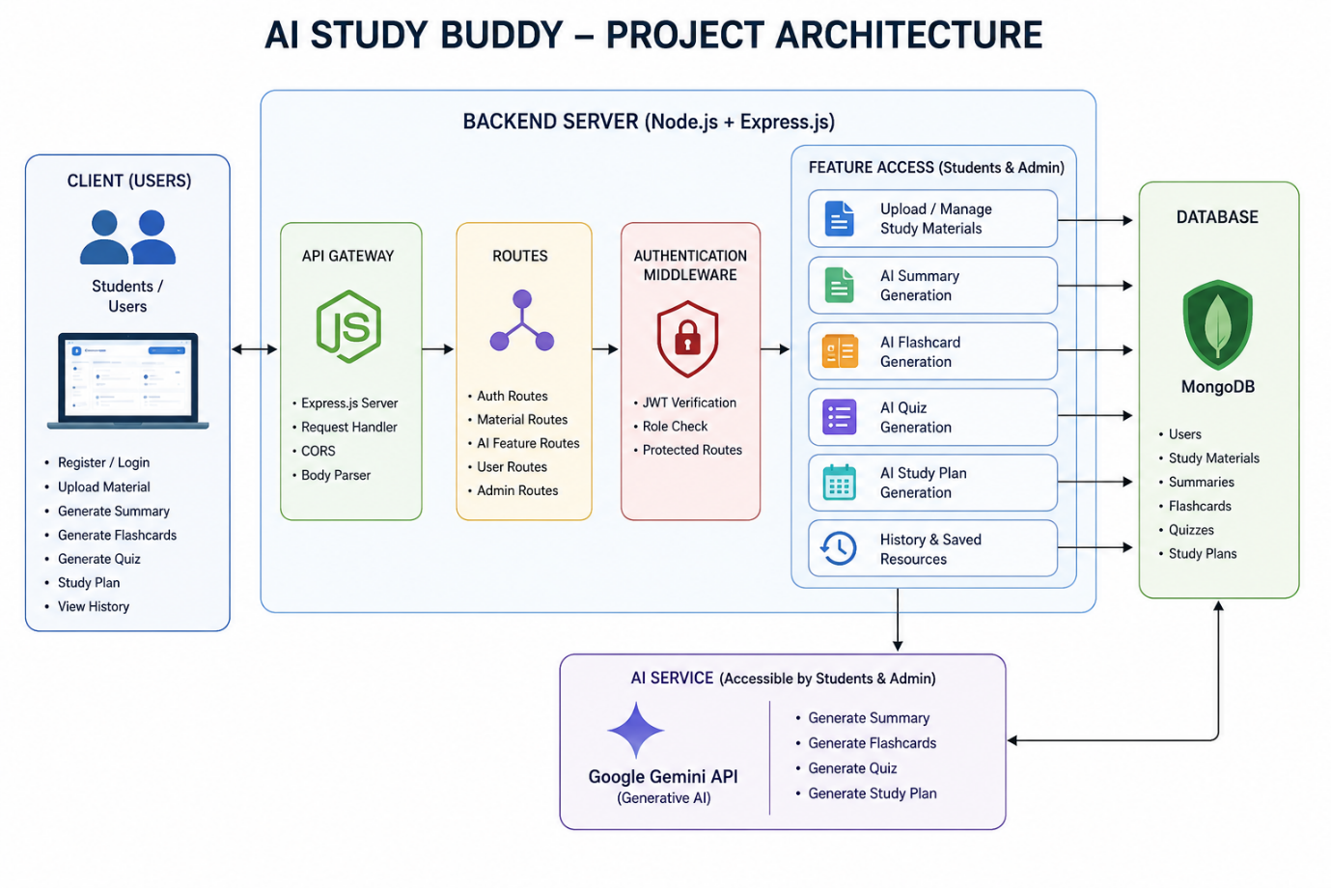
The AI StudyBuddy backend follows a modular RESTful architecture designed to provide secure, scalable, and AI-powered learning services. The system processes client requests through Express.js, validates users using JWT authentication, interacts with the MongoDB database for data storage, and communicates with the Google Gemini AI API to generate intelligent study resources.
The architecture separates authentication, business logic, AI services, and database operations into independent modules, making the application easier to maintain, extend, and debug.
Components Definition
Components Definition for AI StudyBuddy
Student Learning Module
This component allows students to ask questions, read study materials, and take quizzes.
AI Assistant Module
This component gives simple answers, explanations, summaries, and study suggestions to students.
Admin Management Module
This component helps the administrator manage users, learning content, and system activities.

Entity-Relationship (ER) Diagram Description

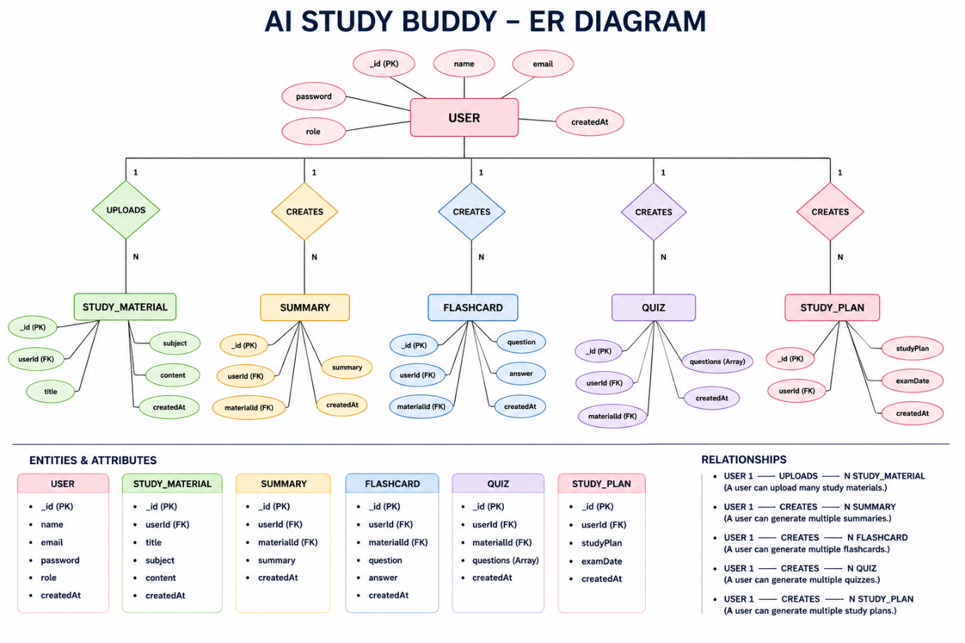
The AI StudyBuddy backend manages data through interconnected MongoDB collections that store user information, study materials, and AI-generated learning resources. Each entity is linked using logical relationships to ensure efficient data management and retrieval.
1. User Entity
Stores the details of registered users and administrators.
Attributes:
- _id (Primary Key - ObjectId)
- name (String, Required)
- email (String, Required, Unique)
- password (String, Hashed)
- role (String - Student/Admin)
- createdAt
2. Study Material Entity
Stores study content uploaded by students for AI processing.
Attributes:
- _id (Primary Key)
- userId (Foreign Key → User)
- title
- subject
- content
- createdAt
3. Summary Entity
Stores AI-generated summaries.
Attributes:
- _id (Primary Key)
- userId (Foreign Key → User)
- materialId (Foreign Key → Study Material)
- summary
- createdAt
4. Flashcard Entity
Stores AI-generated flashcards.
Attributes:
- _id (Primary Key)
- userId (Foreign Key → User)
- materialId (Foreign Key → Study Material)
- question
- answer
- createdAt
5. Quiz Entity
Stores AI-generated quizzes.
Attributes:
- _id (Primary Key)
- userId (Foreign Key → User)
- materialId (Foreign Key → Study Material)
- questions
- createdAt
6. Study Plan Entity
Stores personalized study plans generated by AI.
Attributes:
- _id (Primary Key)
- userId (Foreign Key → User)
- studyPlan
- examDate
- createdAt
Key Relationships
- Student → Subject (One-to-Many): A student can study multiple subjects in the AI StudyBuddy system.
- Subject → Study Material (One-to-Many): Each subject can contain multiple notes, videos, and learning resources.
- Student → Quiz Attempt (One-to-Many): A student can take multiple quiz attempts for different subjects.
- Quiz → Question (One-to-Many): Each quiz contains multiple questions for student practice.
- Student → Progress Report (One-to-Many): A student can have multiple progress reports based on quiz results and completed topics.
- Administrator → Study Material (One-to-Many): An administrator can add and manage multiple study materials in the system.
Key Features
The AI StudyBuddy system provides intelligent learning support through a simple, secure, and user-friendly platform. The major features of the system are as follows:
- User Registration and Login: Students and administrators can securely create accounts and access the system.
- AI Question Answering: Students can ask study-related questions and receive simple explanations from the AI assistant.
- Study Material Management: Students can access notes, summaries, and learning resources for different subjects.
- Quiz Generation: The system creates practice quizzes to help students test their knowledge.
- Personalized Study Plans: Students can generate study schedules based on their subjects and examination dates.
- Progress Tracking: The system records quiz scores and shows students their learning progress.
- Admin Management: Administrators can manage users, study materials, and system activities.
- Secure Data Storage: Student details, quiz results, and learning information are stored safely in the database.
Roles and Responsibilities
Student
A student can create an account and log in to the AI StudyBuddy system. The student can ask questions and get simple explanations from the AI assistant. The student can use study materials, summaries, flashcards, and quizzes for learning. The student can follow the study plan and track their learning progress.
Administrator
The administrator manages student accounts and user details in the AI StudyBuddy system. The administrator adds, updates, and removes study materials when required. The administrator monitors quizzes, study plans, and overall system activity. The administrator protects user data and ensures that the system works properly.
User Flow
The student opens the AI StudyBuddy application and logs in using their account. The student selects a subject or enters a question about a difficult topic.
The AI assistant provides a simple answer, explanation, or study material.
The student can create summaries, flashcards, quizzes, or a study plan.
The system saves the student’s quiz results and learning progress.
The administrator monitors users and manages the study content in the system.

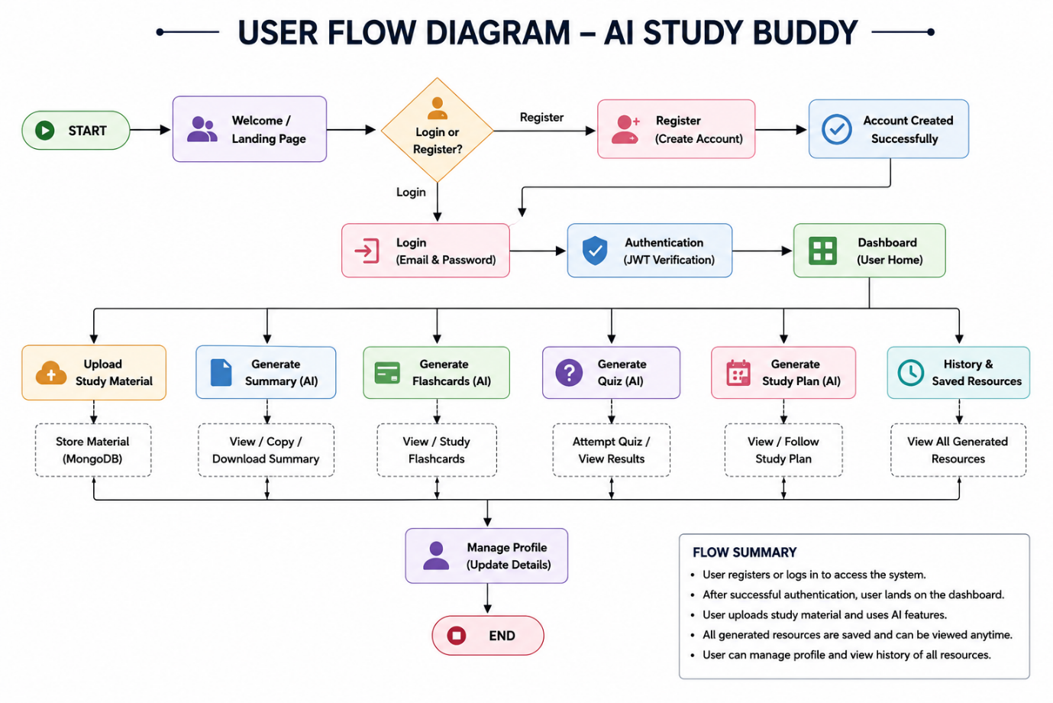

MVC Architecture Pattern

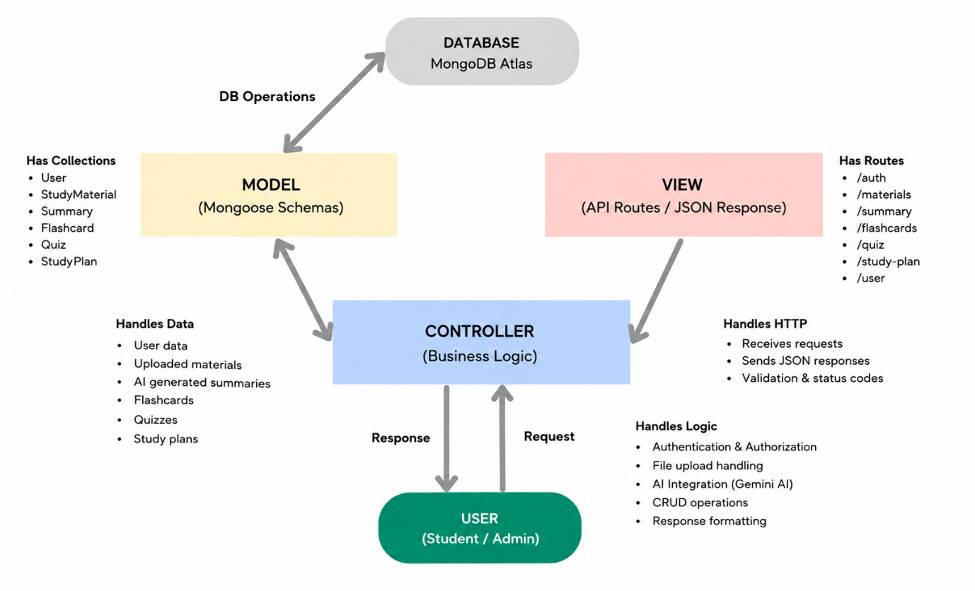
The AI StudyBuddy backend follows the Model-View-Controller (MVC) architecture to organize the application into separate layers, making the code modular, maintainable, and scalable.
Model Layer (Data Layer)
The Model Layer stores student details, study materials, quiz results, and learning progress in the database. It manages the data required for user accounts, subjects, study plans, and AI-generated content. It connects the application to the database and ensures that data is saved, updated, and retrieved correctly.
View Layer (API Response Layer)
The View Layer sends clear responses from the backend to the AI StudyBuddy application. It displays study materials, quiz results, AI answers, and progress information to users. It ensures that the data is returned in a simple and organized format for the frontend.
Controller Layer (Business Logic)
The Controller Layer receives requests from students and administrators through the application. It processes user actions such as asking AI questions, creating quizzes, and generating study plans. It connects the View Layer and Model Layer to return the correct response to the user.
MVC Benefits
MVC separates the AI StudyBuddy application into Model, View, and Controller layers for better organization. It makes the system easier to develop, test, update, and maintain. It also helps developers manage data, business logic, and user responses separately.
Epic 2: Project Setup and Configuration
Creating the Project Folder
- Create a new folder named AI StudyBuddy .
- Open the project folder in Visual Studio Code.
- Initialize the project using Node.js and install the required dependencies.
Project Initialization
Open the project folder in the VS Code terminal and execute:
npm init -y
Install the required dependencies:
npm install express mongoose bcryptjs jsonwebtoken cors dotenv multer @google/genai
Install Nodemon for development:
npm install --save-dev nodemon
Create the Following Files
- index.js
- .env
- package.json
- .gitignore
Create the Following Folder Structure


Environment Configuration
Create a .env file in the project root and configure the required environment variables.
PORT=5000
MONGO_URI=your_mongodb_connection_string
JWT_SECRET=your_jwt_secret
GEMINI_API_KEY=your_gemini_api_key

Epic 3: Backend Development
The backend development of AI StudyBuddy manages user requests, study data, and AI services. It uses APIs to connect the frontend application with the database and AI assistant. It securely stores student details, quiz results, study materials, and learning progress.

Backend Structure


Core System Script Implementations
1. Application Entry Point (index.js)
The index.js file is the main starting point of the AI StudyBuddy backend application.
It initializes the server, connects the application to the database, and loads required settings.
It also starts the API service so students and administrators can use the system.

2. Database Connection (src/utils/db.js)
The db.js file connects the AI StudyBuddy backend application to the MongoDB database.It uses the database connection URL to establish a secure connection when the server starts. It allows the system to store and retrieve student details, study materials, izzes, and progress data.


- Authentication Middleware (src/middleware/auth.js)
The auth.js file checks whether a user is logged in before allowing access to protected features. It verifies the user’s login token and confirms the identity of students and administrators. It helps protect personal data, study materials, quiz results, and user accounts from unauthorized access.


- AI Integration (src/utils/gemini.js)
This utility integrates the backend with the Google Gemini 2.5 Flash API. It sends prompts to the AI model and returns generated responses for summaries, flashcards, quizzes, and study plans.

5. File Upload Middleware (src/middleware/upload.js)
The upload middleware handles study material uploads and validates incoming files before they are processed by the backend.



Backend Development Demo:
AI_Studybuddy_Backend_Demo.mkv

Epic 4: Database Configuration
The database configuration connects the AI StudyBuddy application to the MongoDB database. It uses a secure database URL to store student accounts, study materials, quizzes, and progress data. It ensures that the application can save, update, and retrieve information correctly.
Configure MongoDB
Install Mongoose using the following command:
npm install mongoose
Create Database Connection
Before performing any database operations, establish a connection between the backend and MongoDB using Mongoose. The connection module is initialized during server startup to ensure reliable communication with the database.
Mongoose Schema Definitions
  - User Schema (models/User.js)
- The User Schema defines the structure for student and administrator accounts in the AI StudyBuddy database.It stores details such as the user’s name, email address, password, and role. It helps the system manage user registration, login, and account access securely.

  - Study Material Schema (models/Material.js)
- The Study Material Schema defines the structure for notes, documents, and learning resources in the AI StudyBuddy database.It stores details such as the material title, subject, description, file link, and upload date.It helps students access study resources and allows administrators to manage learning content.


Database Collections
The AI StudyBuddy database consists of the following collections:
- Users – Stores user account and authentication details.
- Study Materials – Stores uploaded learning materials.
API Route Interface Endpoints
The backend exposes RESTful APIs to interact with the database and AI services.
1. Authentication APIs
Handles user registration, login, JWT authentication, and protected route access.
2. Study Material APIs
Allows users to upload, retrieve, update, and manage study materials.
3. AI Feature APIs
Provides endpoints for:
- AI Summary Generation
- AI Flashcard Generation
- AI Quiz Generation
- AI Study Plan Generation
4. Administrative APIs
Provides administrator-only endpoints for managing users and monitoring system activities.
Epic 5: Project Execution
The AI StudyBuddy project is executed by starting the backend server and connecting it to the database. Students and administrators can then access the application through the user interface. The system processes requests for study materials, AI answers, quizzes, study plans, and progress reports.

Running the Backend Server
Install all required dependencies:
npm install
Start the development server:
npm start
After successful execution, the server connects to MongoDB and starts listening for incoming API requests.
API Testing
The backend APIs can be tested using Postman.
1. User Registration
Registers a new user by accepting the required details and securely storing the encrypted password in the MongoDB database.
Endpoint:
POST /api/auth/register
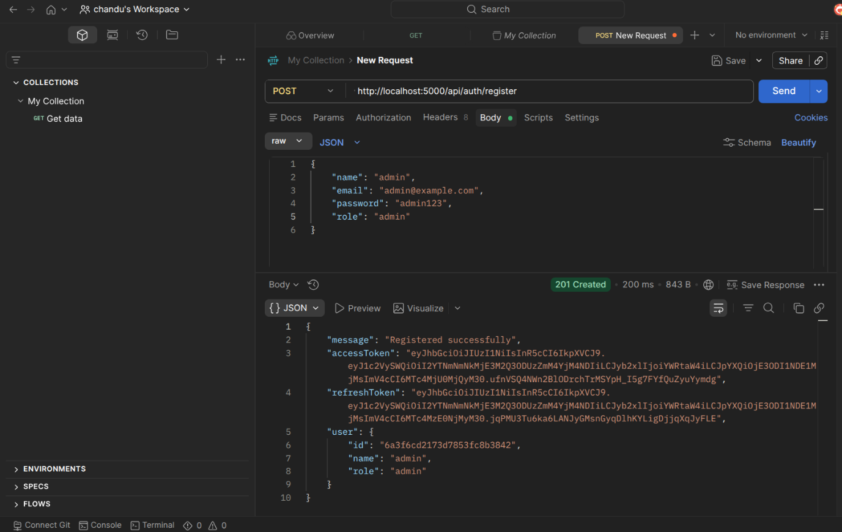
2. User Login
Authenticates the registered user and generates a JWT access token for accessing protected APIs.
Endpoint:
POST /api/auth/login
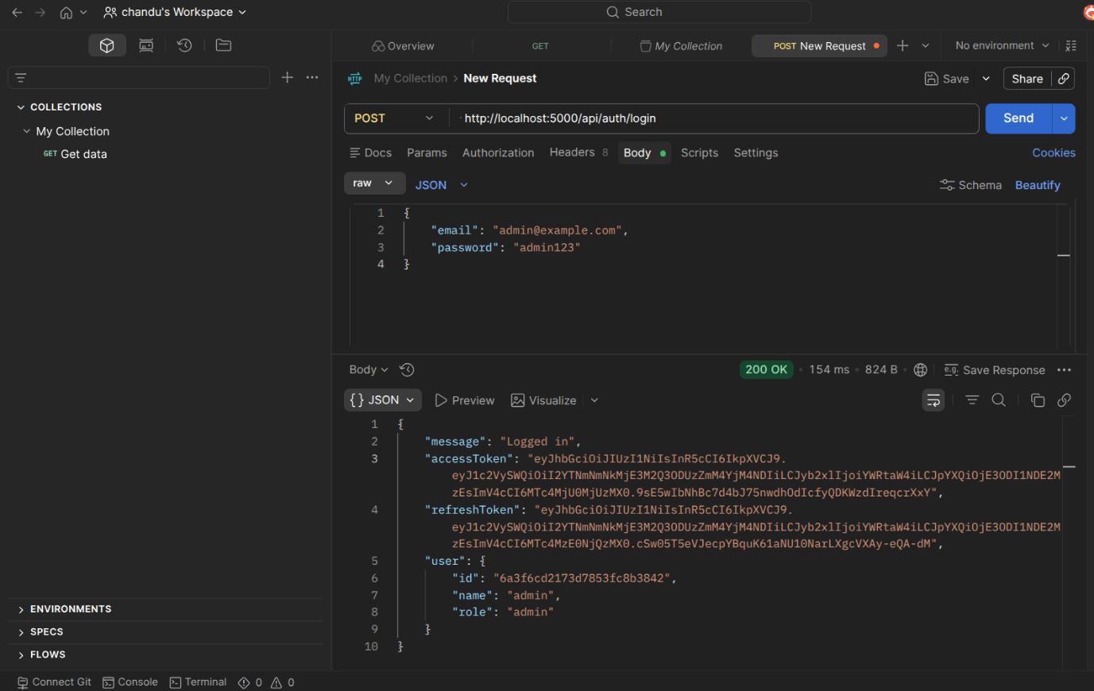
3. Upload Study Material
Allows authenticated users to upload study material that will be used as input for AI-powered content generation.
Endpoint:
POST /api/material/upload
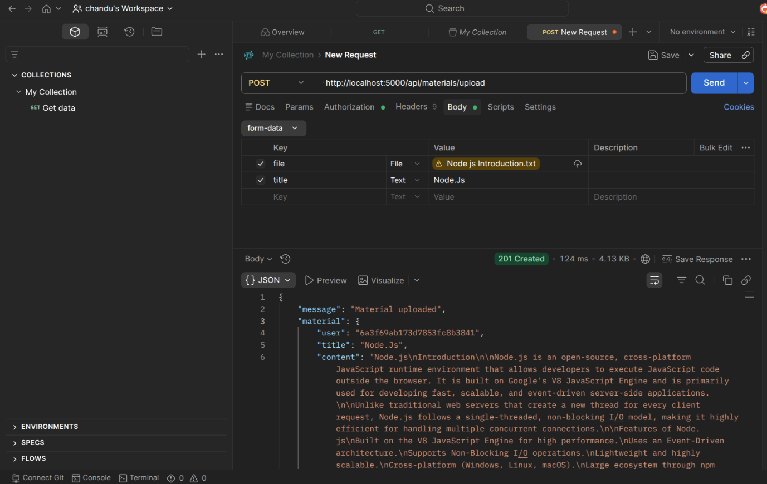
4. Generate AI Summary
Sends the uploaded study material to the Google Gemini API and generates a concise summary.
Endpoint:
POST /api/materials/:id/summarize
5. Generate AI Flashcards
Creates AI-generated flashcards from the uploaded study material for effective revision.
Endpoint:
POST /api/ai/flashcards
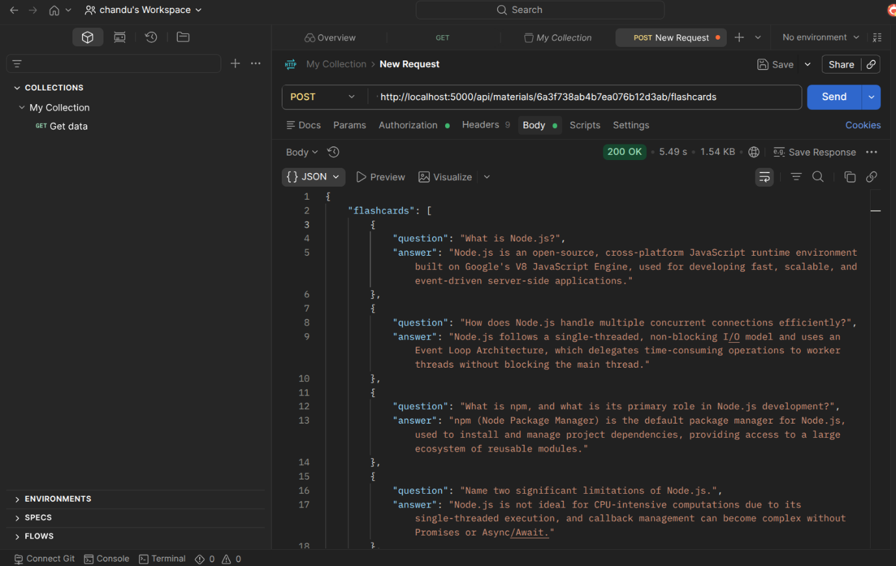
6. Generate AI Quiz
Generates multiple-choice questions from the uploaded study material to help users assess their understanding.
Endpoint:
POST /api/ai/quiz
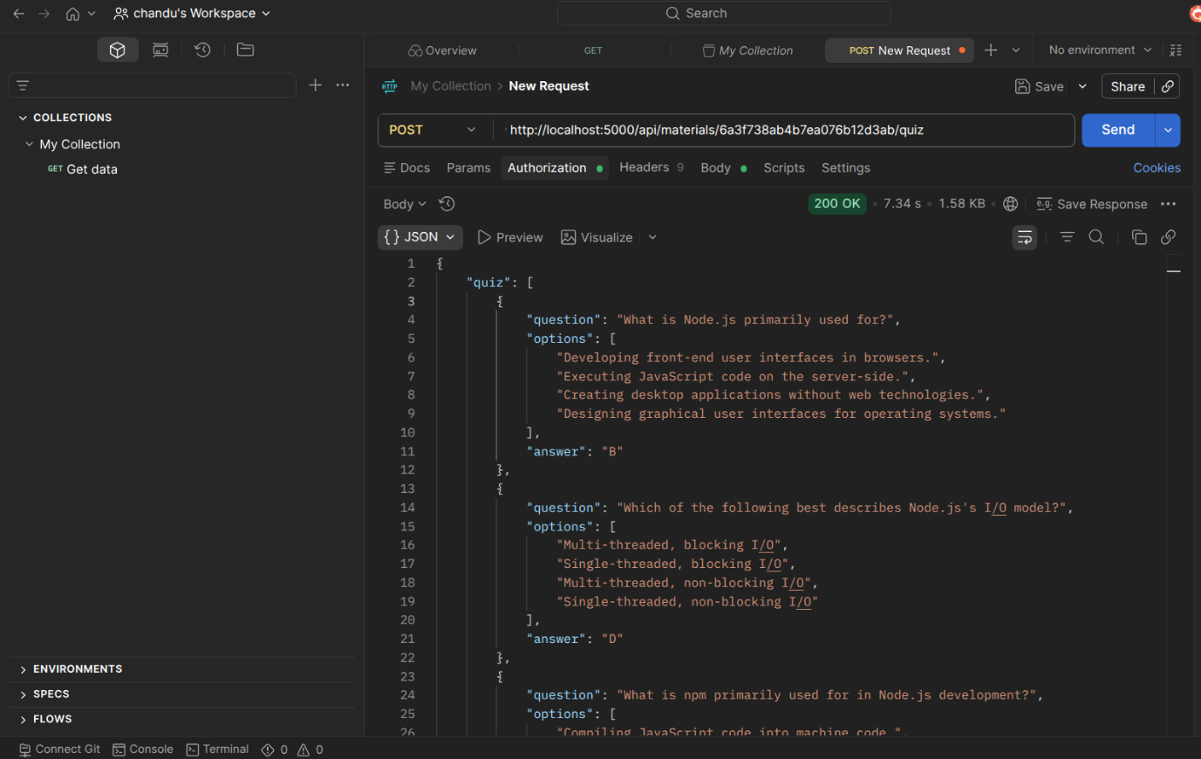
7. Generate AI Study Plan
Creates a personalized study schedule based on the user's learning goals and available study time.
Endpoint:
POST /api/ai/study-plan
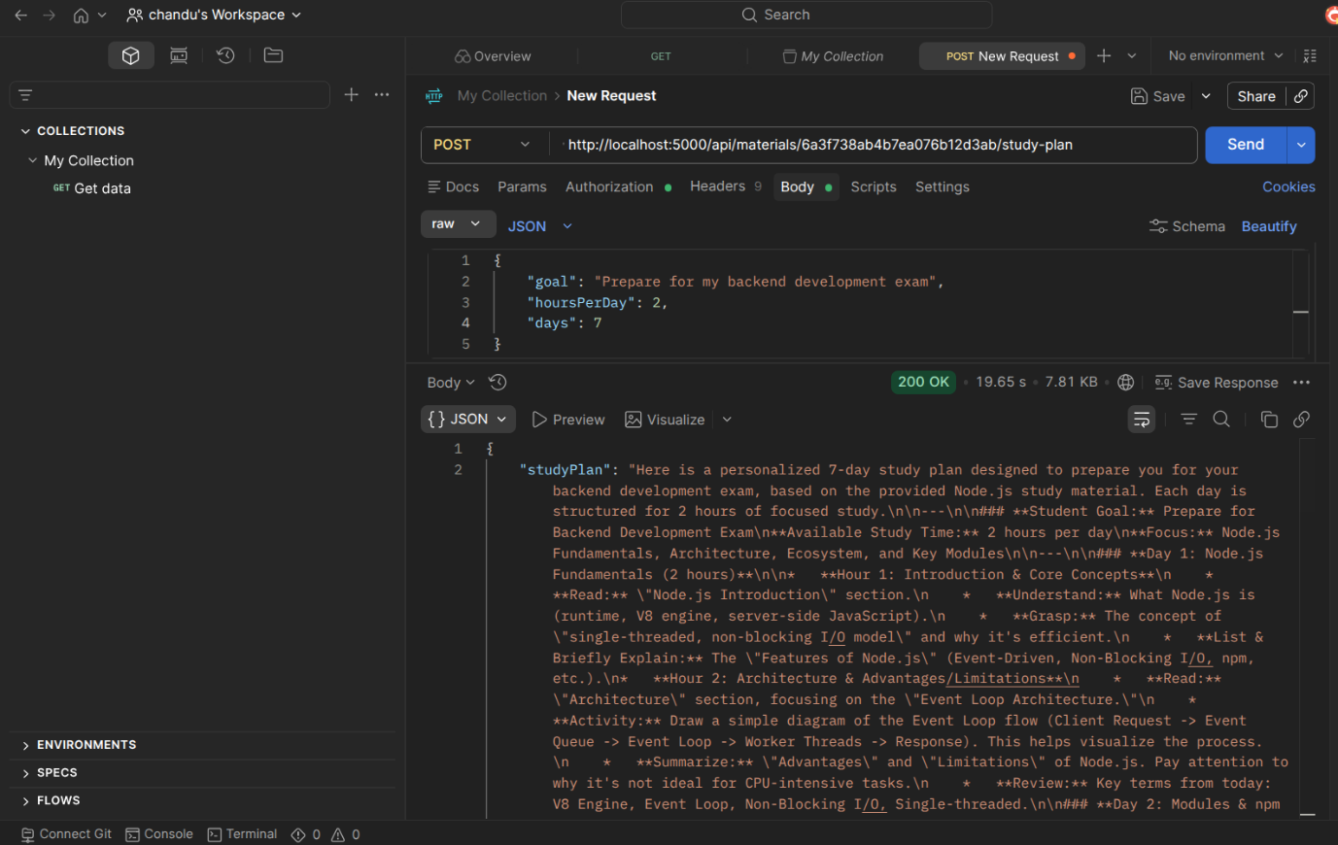

API TESTING LINK : AI_STUDYBUDDY_EXECUTION_DEMO
DEMO VIDEO LINK : AI STUDYBUDDY DEMO VIDEO
Code Drive Link : CODE

